Subject: Recommendation for Angus (Gus) Brumbaugh — Baseball Athlete

To Whom It May Concern,

I am pleased to write this letter of recommendation for Angus "Gus" Brumbaugh, whom I have had the privilege of coaching for the past three years on the Combs High School baseball team. During this time, I have witnessed not only his exceptional athletic ability but also his unwavering dedication, leadership, and sportsmanship.

From his first day on the field, Gus distinguished himself as a disciplined and highly coachable athlete. His technical skills—ranging from precise fielding to consistent, high-level batting— are matched by his strong strategic understanding of the game. He has an impressive ability to read plays, adapt quickly under pressure, and execute with confidence.

Beyond his athletic talent, Gus is a natural leader. He motivates his tearnmates through encouragement, leads by example in both practice and competition, and consistently demonstrates respect for coaches, officials, and opponents. His commitment extends off the field as well, where he balances rigorous training with academic responsibilities and meaningful community involvement.

I am confident that Gus will bring the same level of excellence, integrity, and determination to any team or program he joins. He is the kind of player who elevates those around him and contributes to a winning culture both on and off the field.

Key Accomplishments: 2024/2025 Season
- 1st Team All East Sky Region
- Lead team with 481 Batting Average
- Lead team with 26 hits with 17 RBI's
If you have any questions or would like further insight into Angus (Gus) Brumbaugh abilities and character, please feel free to contact me at (309)212-5928 or Bcalvertl@jocombs.org.
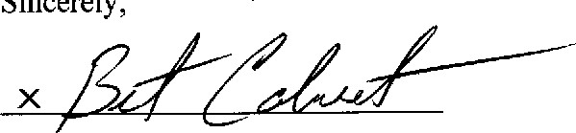
Brent Calvert
Varsity Baseball Coach
Combs High School

