To Whom It May Concern,

I am pleased to write this letter of recommendation for Parker Naehrbass, a student in my AP Language and Composition class. Parker is an exceptional student who consistently demonstrates academic excellence, strong character, and a remarkable work ethic.
In my class, Parker has earned an A while engaging fully in the rigorous demands of AP coursework. He approaches complex readings and writing tasks with thoughtfulness and determination, consistently producing high-quality work. Parker is not only capable but also highly motivated—he seeks feedback, applies it effectively, and continually strives to improve. His discipline and intellectual curiosity make him a standout student in an advanced academic setting.
Beyond the classroom, Parker’s commitment to excellence is evident in every aspect of his life. He maintains an impressive academic record, including a 3.87 unweighted GPA and a 4.6 weighted GPA, while taking multiple honors and AP courses and earning High Honor Roll recognition every semester . His ability to balance such a rigorous academic load with extensive athletic involvement—including years of competitive baseball, football, and varsity swim and dive—speaks to his exceptional time management, perseverance, and resilience .
Parker is also deeply involved in leadership and service. Through his participation in agriscience and FFA, as well as his hands-on work managing responsibilities on his family’s hobby farm, he has developed strong leadership, accountability, and problem-solving skills . Additionally, his volunteer work with organizations such as St. Mary’s Food Bank and Unified Sports reflects his compassion, empathy, and commitment to serving others .
What truly distinguishes Parker is his character. He is dependable, respectful, and
team-oriented, consistently demonstrating integrity in both academic and extracurricular settings. Whether in the classroom, on the field, or in the community, Parker brings a positive attitude and a willingness to work hard—qualities that will undoubtedly contribute to his continued success.
I recommend Parker Naehrbass without reservation. He is a dedicated, well-rounded individual who will be a valuable addition to any academic program or organization. Please feel free to contact me if you need any further information.
Sincerely,
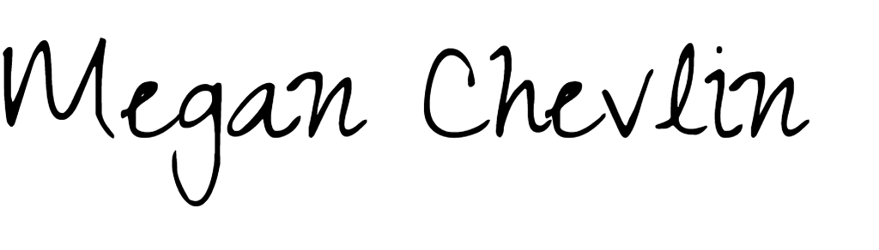

Megan Chevlin
AP Language and Composition Teacher Dual Enrollment ENG 105/106

Canyon View High School

Audit trail

 | Details
 | FILE NAME | P. Naehrbass LoR - 3/23/26, 11:29 AM
 | STATUS | Signed
 | STATUS TIMESTAMP | 2026/03/23  18:30:03 UTC

 | Activity
 | SENT | mchevlin@ aguafria.org sent a signature request to: Megan Chevlin (mchevlin@ aguafria.org) | 2026/03/23  18:29:33 UTC
 | SIGNED | Signed by Megan Chevlin (mchevlin@ aguafria.org) | 2026/03/23  18:30:03 UTC
 |   COMPLETED | This document has been signed by all signers and is complete | 2026/03/23  18:30:03 UTC
The email address indicated above for each signer may be associated with a Google account, and may either be the primary email address or secondary email address associated with that account.

